**Solar Investigations Project**

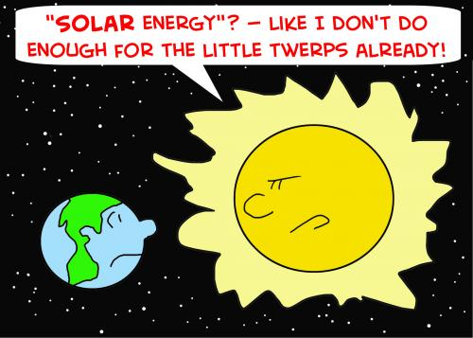

The Sun is obviously fundamental to our planet, it supports life like the cartoon shown above and can cause harm to humans as well as its UV rays can cause cancer.

It is our star at the centre of our solar system and has a diameter of about 1,392,000 km. Its mass is about 2×1030 kilograms, (330,000 times that of Earth) and it accounts for about 99.86% of the total mass of the Solar System. It has a temperature of 1.5 x 107 K at the centre and at its photosphere its 5778K and is mainly made of hydrogen.

However, the purpose of our project is split into two, to determine the rotation period of the Sun using data from the GONG solar telescope on Tenerife, and to investigate one hundred years of sunspot data, to see if any patterns emerge.

[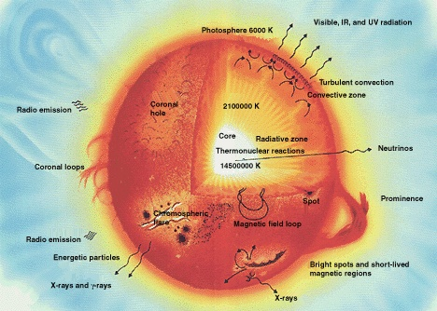](http://upload.wikimedia.org/wikipedia/commons/d/da/Sun_parts_big.jpg)Since 800BC Chinese astronomers have been observing and recording sunspots on the surfaces of the sun. Galileo was one of the first people to accurately record the positions of the sunspots in 1612. Sun spots are temporary phenomena on the photosphere of the sun caused by an intense magnetic activity. Unlike the Earth, the interior of the sun rotates at different rates to the surface, causing a twisting and distorting of the magnetic field inside the sun. This uneven movement is similar to the wrinkling of your bed sheets as you toss and turn in your sleep. The magnetic field lines get twisted which create a high amount of magnetic power. This pushes back the hot gases beneath them and prevents the heat from rising to the surface. This causes a drop in temperature and a sun spot is created. They look darker against the rest of the sun due to the drop in temperature to around 3000-4500K, against the surrounding material at 5780K leaving them clearly visible to an observer. The dark spot is called the Umbra. It has a surrounding area called the Penumbra, which is slightly hotter. Then the even hotter area around that is called the Granule.

There is a recently developed model by the astronomer Mausumi Dikpati that the sun spot cycle acts in a similar way to a conveyor belt, which circulates hot electrified gas called plasma. This plasma is driven between the poles of the sun and to the equator and then back again over a period of around 11.1 years. A sunspot will form early in its cycle and then begins to decay gradually as seen on the graphs below. This leaves a magnetic imprint on the plasma that is moving below it. As the magnetic field circulates the plasma these magnetic imprints are carried towards the poles then back within the sun where they get distorted even more before getting carried out to resurface near the equator. This plasma now forms new sun spots on the photosphere.

Using Microsoft Excel, we imported data from the text file named Sunspot 1900-2008 that came from the GONG (http://gong.nso.edu/) solar telescope, taken through an H-Alpha filter and these observations were taken every day, and as close to noon as the conditions allowed it. After that we created the graphs shown below. As you can see below, the annual graphs barely tell us a pattern as the two graphs do not look very similar. There are no similar peaks or troughs. However, the number of sunspots over the years tells us a very specific pattern.

11 year cycle

This graph shows that the sunspot cycles are asymmetrical, as their activity rises rapidly at the start of the cycle then gradually declines until the end of the cycle. The peak of intensity is called the solar maximum, and the low point is called the solar minimum.

The most famous of these solar minimums is called the Maunder Minimum. This was a period during 1645 and 1715 where very few sunspots where recorded or none at all. This period corresponds to a time on Earth called “the little ice age”, where once ice-free rivers froze over and snow fields remained all year round at lower altitudes.

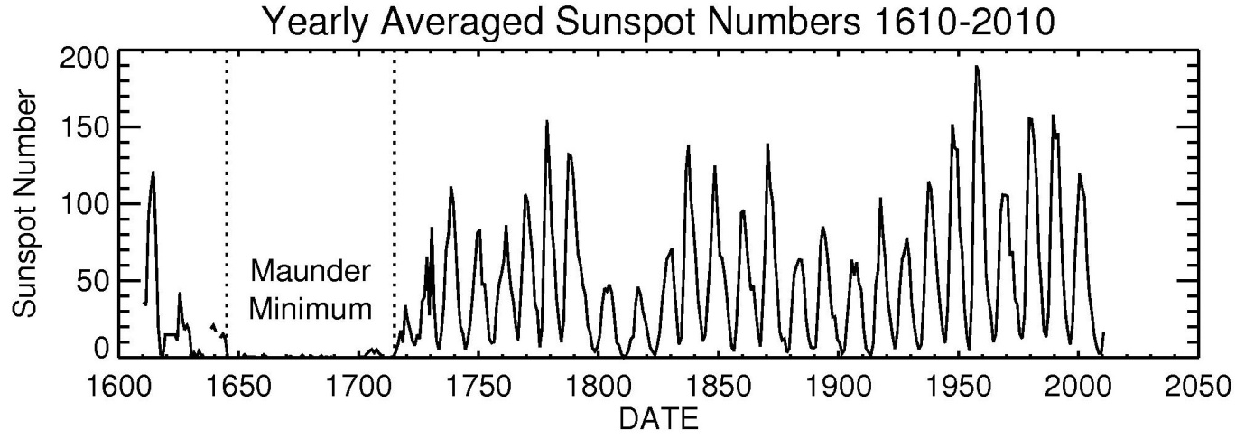

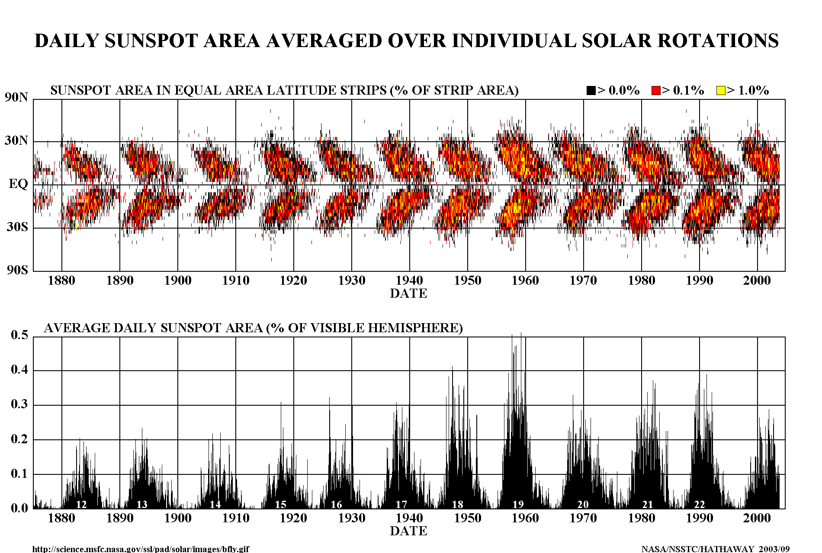But as you can see, sunspots don’t occur randomly but are concentrated over 2 latitude bands on either side of the equator between 30N and 30S. These solar cycles are observed by counting the placements and frequency of sun spots over a period of time. The sun spot number can be calculated by counting the number of sunspot groups then individual sun spots. The sun spot number is equal to the sum of the individual sun spots and the number of groups multiplied by 10.

As the sun and the planets orbit around a centre of gravity, the sun could be 1 million km away from the centre of gravity or it could be right on top of it. The transition of these positions leads to turbulence on the photosphere of the sun which can affect the number of sun spots.

Sun spots are connected with other solar events such as coronal mass ejections (CME’s) and solar flares. CME’s shoot hot plasma from the sun into space, whereas solar flares are a sudden release of energy from the sun. These both send huge amounts of energy and electrically charged particles into the atmosphere which eventually collide with the Earth, and create phenomena such as the Aurora Borealis. These magnetic storms can disrupt and alter radio signals and electrical grids. The solar flares contain high amounts of radiation which could theoretically be a potential hazard to space walking astronauts or passengers on a high flying aircraft. Although there is no evidence to support that there has been any harmful effects from such events.

Astronomers need to be able to view the sun safely in order to learn how it works. This can be damaging to the observers eyes or to special equipment such as telescopes. The energy from the sun can cause the mirrors on the telescopes to overheat and warp which distorts the image. Suitable filters can be used to block out 99.9% of the suns light and heat. Astronomers also need to view the sun in different wavelengths, so special filters are used to block out light from the other wavelengths.

We can also calculate the rotational period of the sun on its axis. We know that at the equator, it takes 25 days for it to rotate and at the poles it takes 36 days. We can then use this information to check our calculations.

We firstly used the software called DS9 which is similar to LTImage. We opened a series of FITS files that range from observations between the dates of 02/03/2012 and 13/03/2012. The data was imported and split into 3 sets of data with four sets of data and we changed the colour to I8 and changed the scale to Histogram. This gives us better colour scheme so that we will be able to find the sunspots more easily. We were then able to find out where the sunspots were and then where they moved. As you can see there is scale on the bottom in Kelvin telling us the temperature of the sunspots and they tend to be around 2500 and 3000K. We recorded the heliocentric coordinates in pixels of the sunspots on each image and then we did this for three sets of data.

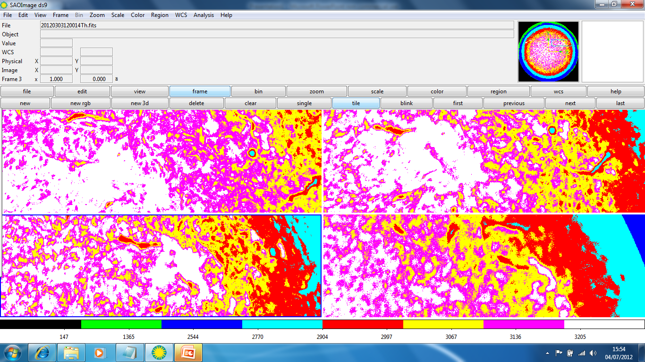

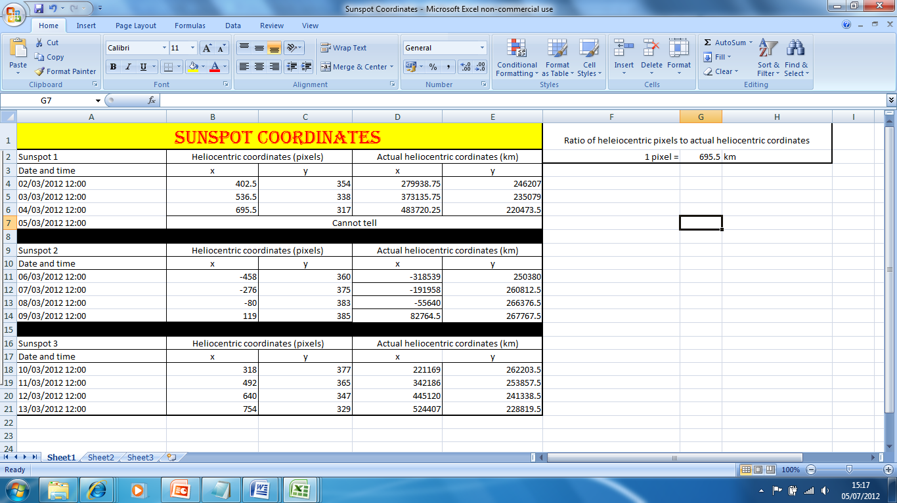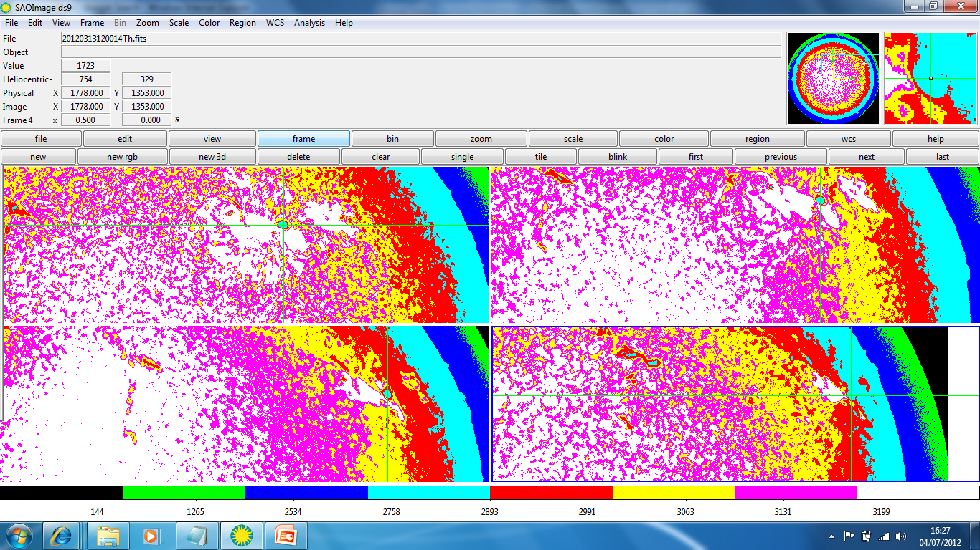

We then calculated the actual distance of the sunspot from the centre of the Sun by calculating the ratio as we determined the radius of the sun by using DS9and it was 1000 pixels. Then by dividing the actual radius by the pixels we can find out how much a pixel represents in real life in km. This is shown above.

Then we used the following formulae below:

The projection of the vector R onto the x-z plane was calculated by:

r =

The angle, , from North to South was calculated by:

The angle,, from East to West was calculated by:

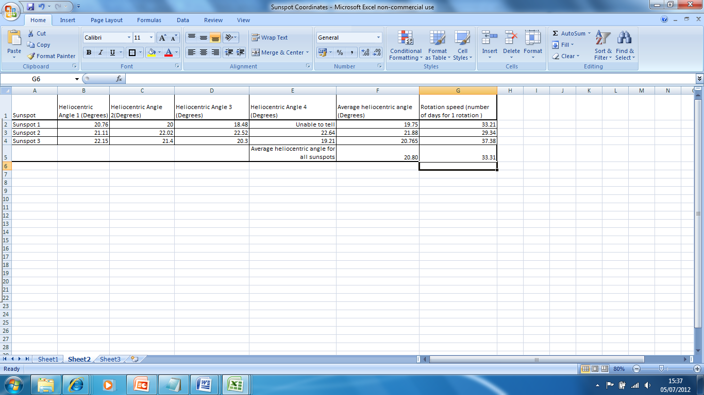

We used these calculations for each value of x and y on each of the sun spots. To find how much the sunspot moved each day we took an average of the change in the angle.

Once we had an average angle we used the following equation to find out how many rotations there were per day.

X = Rotations per day

We then had to invert this number to find how many days for one rotation which is the

We repeated this process for 3 different sun spots and took the averages of all 3 results to find the average time for one rotation of the sun at the average latitude over the 12 days.

To conclude we have determined the rotational period of the sun and it takes 33.31 days for it to rotate once on its axis. But this is only for one average sunspot which is about 20.80 degrees above the Sun’s equator and over one hundred years of sunspot data, we can see that it takes about 11 years for one sunspot cycle and that they occur between the latitudes of 30N and 30S.

References:

<http://solarscience.msfc.nasa.gov/SunspotCycle.shtml>

**Author:** Dr. David H. Hathaway, david.hathaway @ nasa.gov   
**Curator:** Mitzi Adams, mitzi.adams @ nasa.gov   
  
Last Updated: July 02, 2012

<http://www.mps.mpg.de/homes/solanki/saas_fee_39/SaasFee39_Handout_L3.pdf>

<http://www-das.uwyo.edu/~geerts/cwx/notes/chap02/sunspots.html>

|  |  |
| --- | --- |
| *B. Geerts and E. Linacre* | 12/'97 |

<http://adsabs.harvard.edu/abs/2004AAS...205.1002S>

<http://en.wikipedia.org/wiki/Sunspot#Early_observations>

<http://en.wikipedia.org/wiki/Sun>

<http://solarscience.msfc.nasa.gov/images/ssn_yearly.jpg>

Space Science by Louise K. Harra and Keith O. Mason published 2004 page 197

The Manic Sun by Nigel Calder published 1997

Sky at Night magazine by BBC July 19th 2012 page 20

The Sun as a Star by Stuart Jordan published 1981